PYTHON

Lab-06

Milan Nain

CSE-4C

2k19CSUN01150

1. Create the following dictionary
   1. Key value
   2. A 10
   3. B 20

d={‘A’:10,’B’:20}

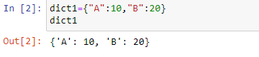

1. Create a dictionary with different datatypes for keys

d1={‘A’:1,2:’two’,3.0:’Three’}

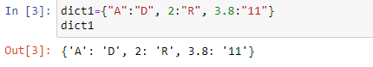

1. Print all the items of a dictionary

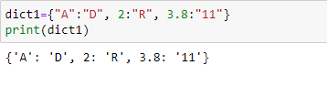

1. Delete an element of a dictionary

del(d[‘B’])

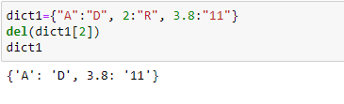

1. Delete full dictionary

del(d)

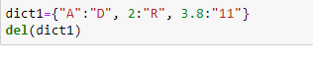

1. Print a value for a key

print(d[‘A’])

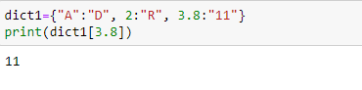

1. To check if a key id present in a dictionary

‘A’ in d

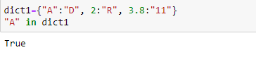

1. Update a value of a key

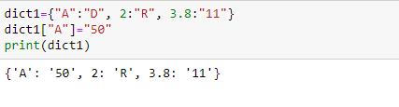

1. Add a new key value pair

d[‘C’]=90

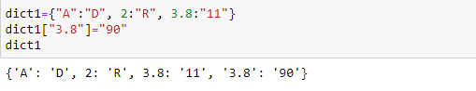

1. Print dictionary for keys{1,10} and values as square of keys

{1:1,2:4,3:9,4:16,5:25…..10:100}

d={}

for I in range(1,11):

d[i]=i*i

print(d)

1. Print nested dictionary

dict={1:{‘A’:10,’B’:20}}

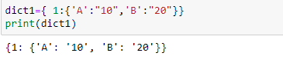

1. Concatenate three dictionaries

Sample Dictionary :  
dic1={1:10, 2:20}  
dic2={3:30, 4:40}  
dic3={5:50,6:60}  
Expected Result : {1: 10, 2: 20, 3: 30, 4: 40, 5: 50, 6: 60}

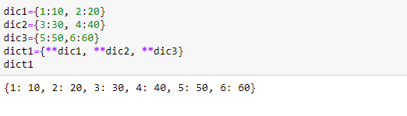

1. Sum all the values of a dictionary

for I in d.keys():

sum=sum+d[i]

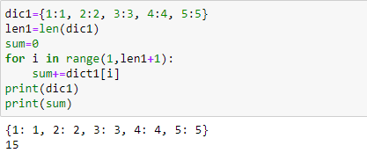

1. Accessing an element of a nested dictionary

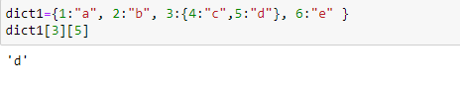

16. Insert factorial of keys in values. And print dictionary

d={1:1,2:2,3:6,4:24,5:120….}

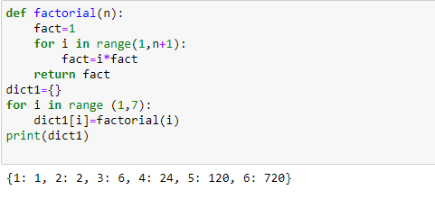

Sets

1. Write a program to create a set

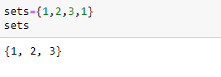

1. Write a program to add an element to set

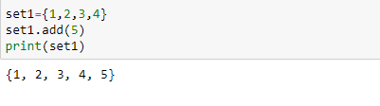

1. Write a program to add multiple items using update function

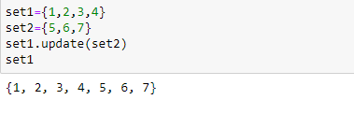

1. Write a program to find length of a set

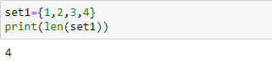

1. Write a program to remove value from a set

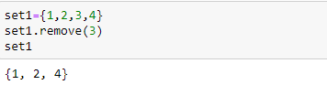

1. Write a program to pop an element from a set

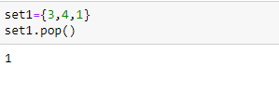

1. Write a program to update a set

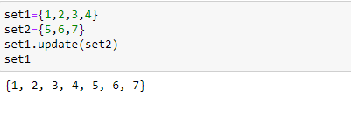

1. Write a Python program to create an intersection of sets.

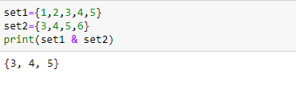

1. Write a Python program to create a union of sets.

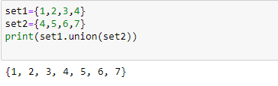

1. Write a Python program to clear a set.

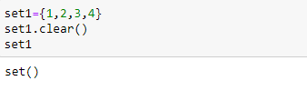

1. Write a Python program to issubset and issuperset.
2. Write a Python program to create set difference.

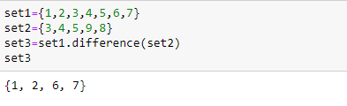

1. Write a Python program to create a symmetric difference.

